Innovate Canmore Code Play for Kids
Introduction Material

Organized By
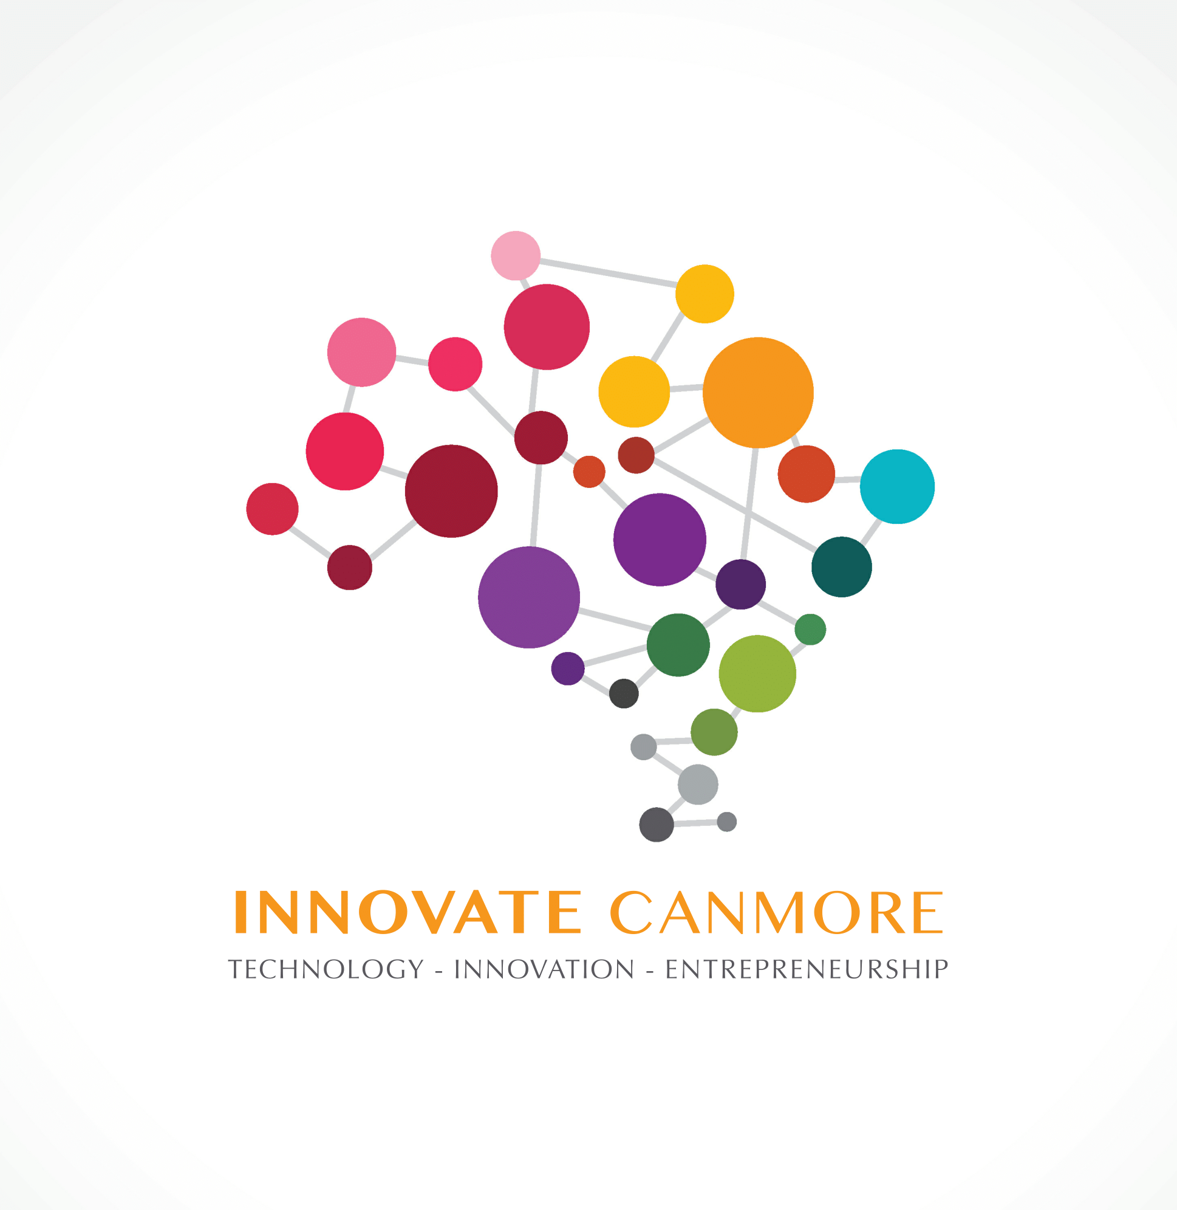

Sponsored By

Hello and welcome to the Innovate Canmore Code Play for Kids course! This document contains the information you need to prepare your child (or children) for the course and what to expect from the course. Please contact us at email: president@bowvalleychamber.com if you have any further questions.

To formally register a participant please make sure you have completed a registration form for each child and return that to the above email address.

What is Coding?
Using a computer programming language to instruct the computer on what to do.

Why should my child learn Coding?
Coding (also known as computer programming) is a skill that teaches your child how to problem-solve inside a formal framework. As well as helping with learning, coding is also a fun hobby and can lead to a rewarding career as a Computer Software or Hardware Engineer. To learn more about careers in computing see this link - https://www.thebalance.com/what-does-a-computer-programmer-do-525996.

Does my child need to have a certain minimum level of knowledge to attend the course?
Your child must be able to read and write at a Grade 3 level and have some familiarity with using a web browser and typing on a keyboard.

Where and when will the Innovate Canmore Code Play for Kids take place?
There are two evening programs offered; Fall and Spring. Both courses will be conducted at Bow Valley College Canmore Campus over an 8 week period; however, some weeks will not have classes due to statutory holidays or instructor availability. A full class schedule will be provided on the first day of classes.

Can I attend the Code Play course too?
Yes! We encourage parents to sit with their child and join in. We will be asking for at least one parent volunteer per evening (there will be a sign-up sheet on the first night for this). However, if you are unable to stay with your child that is also fine. Just be warned they may end up coding better than you can!

What material is this course based off?
The course will be based on the Creative Computing Curriculum developed by a team at the Harvard Graduate School of Education. This is a highly regarded curriculum developed by education experts at Harvard and more information on the design of the course can be found here - http://scratched.gse.harvard.edu/guide/

What kind of computers and programming languages will be used?
Computers will be provided by Bow Valley College. Any computer with a keyboard is acceptable for practice at home (i.e. not a phone or tablet). The Scratch programming language from MIT will be used for the course. It is available online through a web browser, or you can download a desktop application version. https://scratch.mit.edu/.

Is there anything me or my child should be doing ahead of the first lesson?
YES!
- Go to https://scratch.mit.edu/ and create a username and password for your child to you the online, web-based version of Scratch.
- Make sure you send your child’s username and password with them on a piece of paper when they attend class.

Does my child need to provide anything for the course? For example, a notebook.
No. There is nothing your child needs to provide aside from the pre-registration of a scatch.mit.edu username and password as mentioned above.

Who is leading this course?
Dr. Stephen Bates is the CTO of Eideticom and is a renowned expert on topics like NVMe, RDMA, TCP/IP and NVM. He has worked on a range of complex storage and communication systems include the NVMe controllers and PCIe switches developed by his former employer Microsemi (formerly PMC-Sierra). He enjoys working at the interface between hardware and software and is a active contributor to the Linux kernel. Before Eideticom he was the CTO at PMC-Sierra and prior to that was an Assistant Professor in Computer Engineering at The University of Alberta. He holds a PhD from The University of Edinburgh, Scotland and lives in Canmore with his wife and three kids.

Dr. Matthew Brown is a computational neuroscientist with 20 years of experience programming in a professional context. He is scientist and Adjunct Professor in Computing Science at the University of Alberta. His research background includes machine learning (artificial intelligence), brain imaging, automated diagnostics and prognostics for mental health, among other things. He is also a consultant (programming, websites, data analysis services) and entrepreneur (founded Puzzle Rock Coding Inc.). He lives in Canmore with his wife and four children.

What is the cost? Why is it free?
The course is free. All instructors and several local entities (like Innovate Canmore and Bow Valley College) have donated their time and resources because they feel enabling children with coding skills is in the long-term interest of both the child and the community at large.

What will my child have learned by the end of the program?
You child will have learnt how to develop simple programs in the Scratch programming environment. They will also have learnt some of the fundamental components of computer programming such as logic, conditional statements, branches (e.g. “if this, then that”) etc.

Will there be follow-on courses available to further my child’s experience gained in this course? For example, weekend workshops or a short summer camp.
Yes. This summer Innovate Canmore has collaborated with artsPlace to deliver three “Arts & Tech” Summer Camps and will continue to develop additional programming courses for a wider range of age groups, including the new Fall 2019 Coding for Adults program in collaboration with artsPlace.

Will my child be supervised until collected at the conclusion of each class?
Yes! We will make sure both the instructor and at least one parent volunteer are present every evening. The instructor will stay on site until all children are collected, but please do be prompt in collecting your child, or contact the instructor via cellphone if you become unavoidably delayed. Instructor cell phone numbers will be provided on the first evening of the course.

******

